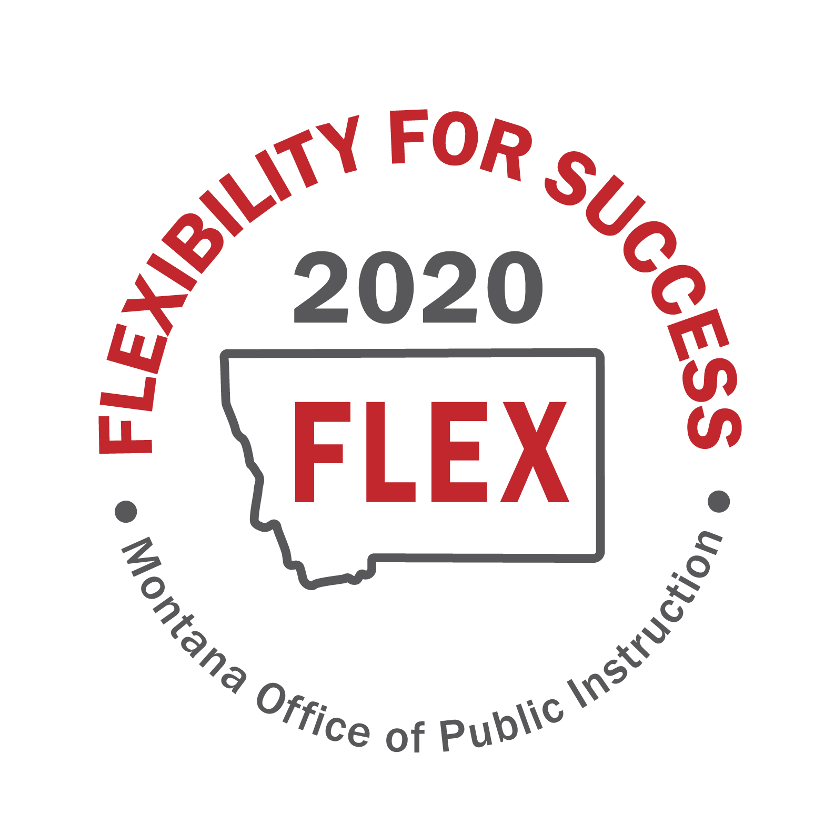

“MT FLEX2020” Task Force
Session 3
June 10, 2020
Break-Out Group Notes-D

Focus Group: D-Fostering and supporting local innovation
Note Taker: Lona Running-Wolf
Group Members: Dinny Bennett, Forsyth Public Schools Superintendent
Michelle Halberg, Special Education Director, Gallatin-Madison Special Education Cooperative
Gregory Dern, Roy Public Schools Superintendent
Wade Sundby, Glasgow Public Schools Superintendent
Pad McCracken, Lead Staff, Education Interim Committee
Montana Legislative Services
Jon Konen, Great Falls Public Schools Principal

Two sections are included below:
- Section 1: An outline of the work conducted during the break-out sessions
- Section 2: Notes capturing the focus group’s prioritization of recommended flexibilities, action plans, and consensus vote outcome

Section 1: Outline of the work conducted during the break-out sessions
Break-Out Work | Notes
Break-Out Session 1: Prioritizing Recommended Flexibilities (10mins) | The group used the prioritization matrix to prioritize the group’s flexibilities:  1. Expand the Transformational Learning Bill for remote and blended learning models. The grant process needs to be funded in a way to have more applicants. Self-directed philosophy is needed.  2. Legislative considerations or waiver process that empowers Districts to design their own Innovative paradigm/model that fits their community needs; bundles local, state, and federal flexibilities; and provides time for school communities to plan, implement and evaluate the new paradigm.  3. Request OPI to set up regional support teams and PD for Blended Learning, Remote Learning, and Personalized Learning and Leadership Networks.  4. Develop avenues for Parent and Community Resources and Tools for Remote Learning  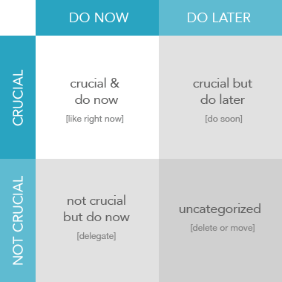
Whole Group (10 minutes) | The group facilitator shared-out each group discussion by answering the following question: (2 mins)  What flexibilities did you identify as Crucial and Do Now and Crucial Do Later Items?
Break-Out Session 2: Mapping out Action Plans and Consensus Building (30 minutes) | Starting with the Crucial and Do Now flexibilities, the group mapped out an action plan.  The group took a vote to establish consensus on the action steps  - Using a scaled numerical system, each task force member takes a vote on the recommended flexibility action plans:  - 3 – Strongly Agree  - 2 – Agree  - 1 – Disagree  - 0 – Strongly Disagree  - 66% of task members must have consensus with votes 2 or 3 (for explanatory purposes depending on group size-5/7, 4/6, 5/8 are required for a consensus vote).  - Any 0 or 1 submissions will have the opportunity to engage in discussion and a subsequent vote. The overall score for each vote and any standing Disagree and Strongly Disagree responses will be noted.

Section 2: Notes capturing the focus group’s prioritization of recommended flexibilities, action plans, and consensus vote outcome
Group Identified Flexibilities:  - Potential Legislative Policy  - Funding Needs  - Regulation Updates  - Waiver Considerations | Draft action steps to enact these flexibilities and make them useable:  - What do we need to do?  - Who needs to be involved to enact the flexibilities?  - How long will it take to implement the flexibility?  - What are the stakeholder requirements?  - What resources would be needed?  - What are the risks involved in enacting the flexibility?  - What are the implications on student success?
1. Expand the Transformational Learning Bill for remote and blended learning models. The grant process needs to be funded in a way to have more applicants. Self-directed philosophy is needed.  Priority: Circle One  - Crucial and Do Now  - Crucial but Do Later  - Not Crucial but Do Now  - Uncategorized | Action Plan:  - Align transformational learning with assurances standards  - Stakeholder engagement  - Share a comprehensive document with existing flexibilities  - Expand Transformational Learning opportunities  - Review of first-come, first-served process/alternatives  Consensus Votes:  Vote 1:  3: 3  2:  1:  0:  Score: 100%  Vote 2:n/a  Notes for 1 or 0:
2. Legislative considerations or waiver process that empowers Districts to design their own Innovative paradigm/model that fits their community needs; bundles local, state, and federal flexibilities; and provides time for school communities to plan, implement and evaluate the new paradigm.  Priority: Circle One  - Crucial and Do Now  - Crucial but Do Later  - Not Crucial but Do Now  - Uncategorized | Action Plan:  - How to incorporate flexibilities into EOPs or emergency declarations  - Desire for specific examples of what districts can’t do- what are actual barriers and what are perceived barriers  - Student seat time- pupil instruction hour requirement flexibility/attendance  - Multi-student households and strain on technology  Consensus Votes:  Vote 1:  3: 3  2:  1:  0:  Score: 100%  Vote 2:n/a  Notes for 1 or 0:
3. Request OPI to set up regional support teams and PD for Blended Learning, Remote Learning, and Personalized Learning and Leadership Networks.
Priority: Circle One
- Crucial and Do Now
- Crucial but Do Later
- Not Crucial but Do Now
- Uncategorized
4. Develop avenues for Parent and Community Resources and Tools for Remote Learning
Priority: Circle One
- Crucial and Do Now
- Crucial but Do Later
- Not Crucial but Do Now
- Uncategorized

